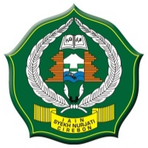
KARTU TANDA MAHASISWA
INSTITUT AGAMA ISLAM NEGERI
SYEKH NURJATI CIREBON
Jalan Perjuangan By Pass Sunyaragi Telp. (0231) 481264 Faks. (0231) 489926 Cirebon 45132, www.syekhnurjati.ac.id
Nama Lengkap :___________________________________________________________________
N I M : ___________________________________________________________________
Fakultas/ Jurusan : ___________________________________________________________________
Tempat, Tanggal Lahir : ___________________________________________________________________
Alamat Lengkap & No. HP : ___________________________________________________________________
:____________________________________________________________________

Cirebon,
Kasubag Kemahasiswaan
dan Alumni,

Dody Dahwana Putra, SEI,MAB
Mahasiswa,

Pas Foto
3x4

......................................

